**USER’S MANUAL**

**Register Page**

* Input fields to register and click submit
* Click ‘Go to Login’ if you have account already.

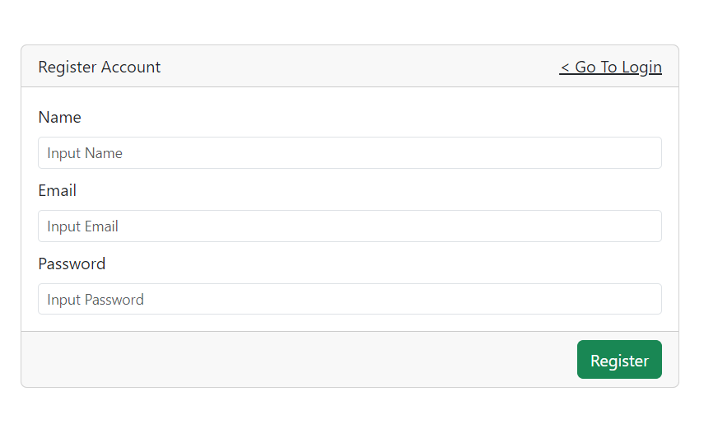

**Login Page**

* Input fields to login and click submit
* Click ‘Register’ go to Register Page

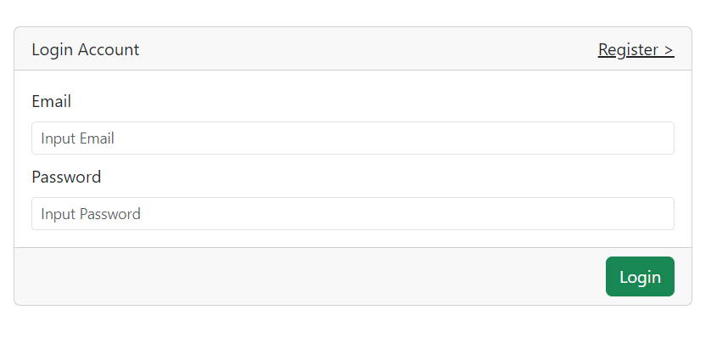

**Main Page**

* This is the home page.
* Click login at the header navigation to login or create account
* Click ‘Add Todo’ to create task
* Click ‘See Archives’ to see all archives list
* Filled Sorting Section based on what you want to sort.
* Filled Filter Section based on what you want to search

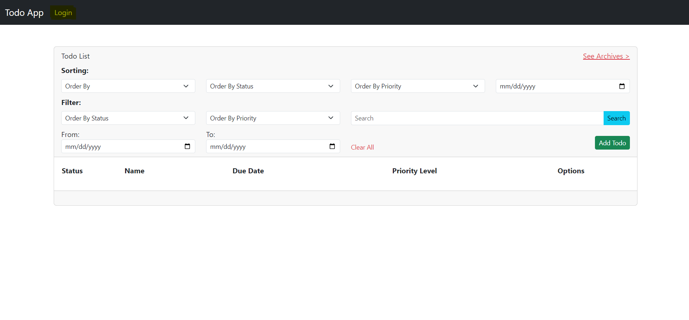

**Todo Form Page**

* Create/Update form for creating a task.

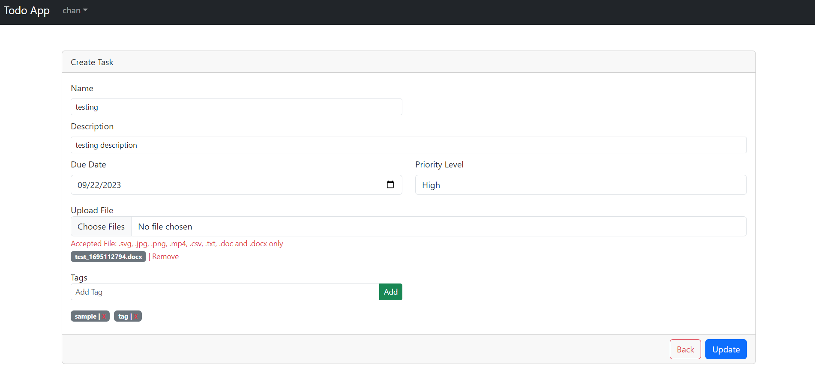

**Archive List Page**

* Click Restore to restore task and move to todo list.
* Click Delete to permanently delete that task
* Archived automatically deleted after 7 days based on that day you archive a task.

